**Assignment -HTML**

1. Are the HTML tags and elements the same thing?

No, HTML tags and elements are not the same thing.

* Tags are part of the HTML markup and are used to create HTML elements. Tags usually come in pairs: an opening tag (e.g <p>) and a closing tag (e.g</p>).
* Elements consist of the opening tag, content (if any), and the closing tag.
* For example,



is a paragraph element.

2. What are tags and attributes in HTML?

* Tags are used to mark up the start and end of an element in HTML. Tags are enclosed in angle brackets, e.g., <tagname>content</tagname>.
* Attributes provide additional information about an element and are included within the opening tag. They are defined by a name and value pair, e.g., <tagname attribute="value">.

3. What are void elements in HTML?

Void elements (also known as self-closing or empty elements) are HTML elements that do not have any content and do not require a closing tag. Examples include <img>, <br>, <hr>, <input>, and <meta>.

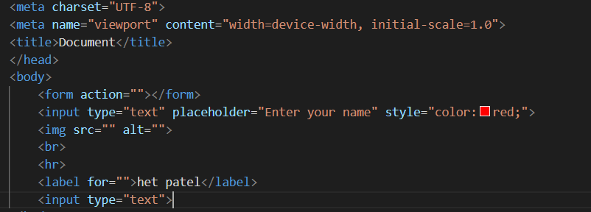

4. What are HTML Entities?

HTML entities are used to represent special characters that cannot be included directly in the HTML code. They are written as &entity_name; or &#entity_number;. For example, &amp; represents &, and &#169; represents the © symbol.

5. What are different types of lists in HTML?

There are three types of lists in HTML:

* Ordered lists (<ol>): A list of items in a specific order, typically numbered.
* Unordered lists (<ul>): A list of items without a specific order, typically bulleted.
* Definition lists (<dl>): A list of terms and their definitions, with <dt> for terms and <dd> for definitions.

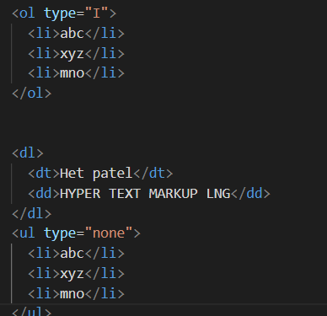

6. What is the ‘class’ attribute in HTML?

The class attribute is used to assign one or more class names to an HTML element. Classes can be used to style elements with CSS and to manipulate elements with JavaScript. Multiple classes are separated by spaces.

7. What is the difference between the ‘id’ attribute and the ‘class’ attribute of HTML elements?

* The id attribute assigns a unique identifier to an HTML element. Each id must be unique within the HTML document.
* The class attribute assigns one or more class names to an element, which can be shared by multiple elements in the same document.

8. What are the various formatting tags in HTML?

Formatting tags in HTML are used to apply styles to text. Common formatting tags include:

* <b>: Bold text
* <i>: Italic text
* <u>: Underlined text
* <strong>: Strongly emphasized text (usually bold)
* <em>: Emphasized text (usually italic)
* <mark>: Highlighted text
* <small>: Smaller text
* <del>: Deleted text (strikethrough)
* <ins>: Inserted text (underline)
* <sub>: Subscript text
* <sup>: Superscript text



9. How is Cell Padding different from Cell Spacing?

* Cell Padding: The space between the cell content and the cell border. It is controlled using the padding attribute in CSS.
* Cell Spacing: The space between individual cells in a table. It is controlled using the border-spacing property in CSS.

10. How can we club two or more rows or columns into a single row or column in an HTML table?

* Rows: Use the rowspan attribute in a <td> or <th> element to span multiple rows.
* Columns: Use the colspan attribute in a <td> or <th> element to span multiple columns.

Example:

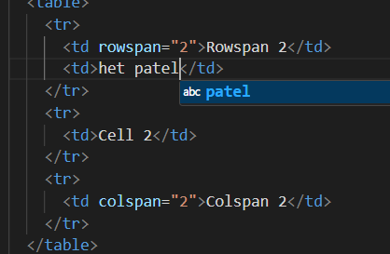

11. What is the difference between a block-level element and an inline element?

* Block-level elements: Occupy the entire width of their parent container and start on a new line. Examples include <div>, <p>, <h1>, <ul>, and <li>.
* Inline elements: Occupy only the width required by their content and do not start on a new line. Examples include <span>, <a>, <img>, <strong>, and <em>.

12. How to create a Hyperlink in HTML?

To create a hyperlink, use the <a> tag with the href attribute specifying the URL.

Example: 

13. What is the use of an iframe tag?

The <iframe> tag is used to embed another HTML document within the current document. It can display web pages, videos, maps, etc.

Example:



14. What is the use of a span tag? Explain with example?

The <span> tag is an inline container used to group text or elements for styling purposes or to manipulate with JavaScript. It does not inherently represent anything.

Example:



15. How to insert a picture into a background image of a web page?

Use CSS to set a background image for an element (e.g., <body>, <div>).

Example:

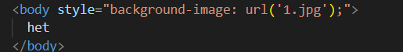

16. How are active links different from normal links?

* Normal links: Links that have not been clicked or interacted with.
* Active links: Links that are currently being clicked or interacted with. They are usually styled using the :active pseudo-class in CSS.

Example:

html

Copy code

<style>

a:link { color: blue; }

a:visited { color: purple; }

a:hover { color: red; }

a:active { color: orange; }

</style>

17. What are the different tags to separate sections of text?

Different tags used to separate sections of text include:

* <div>: A block-level container for content
* <p>: Paragraph
* <hr>: Horizontal rule (line)
* <br>: Line break
* <section>: A section of content
* <article>: An independent piece of content
* <aside>: Content tangentially related to the main content
* <header>: Header for a document or section
* <footer>: Footer for a document or section
* <nav>: Navigation links

18. What is SVG?

SVG (Scalable Vector Graphics) is an XML-based format for describing vector graphics. It allows for images to be scaled infinitely without loss of quality.

Example:

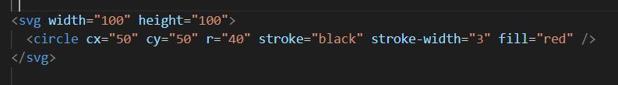

19. What is difference between HTML and XHTML?

* HTML (HyperText Markup Language): A markup language for creating web pages. It is more lenient with syntax rules.
* XHTML (Extensible HyperText Markup Language): A stricter version of HTML that follows XML syntax rules. Tags must be properly closed, nested, and in lowercase.

20. What are logical and physical tags in HTML?

* Logical tags: Describe the meaning or structure of the text. Examples include <em>, <strong>, <cite>, and <dfn>.
* Physical tags: Describe the appearance of the text. Examples include <b>, <i>, <u>, and <tt>.

Logical tags are generally preferred as they provide semantic meaning to the content.